**Algae sampling protocol**

**1. Pelagic algae**

**1.1. Sampling**

*In situ* sampling is rather opportunistic: sample any ‘pelagic’ algae collected from plankton nets, trawl, the rosette (it occurred during Abraços 1), etc. If pelagic algae are visible, do your best to collect samples (e.g. specific bongo profiles, shrimping net).

**1.2. At sea samples conservation**

Collected algae will be used for biological purpose (taxonomy, biomass, associated fauna, etc.) and molecular biology.

Molecular biology purpose

Algae of the genus *Sargassum* or other complete specimens of algae (full coloured and intact) will be used for molecular biology purposes. Before fixing the entire sample in formaldehyde (see below) take a small piece of ‘young vegetative thallus’. Clean the piece (remove epiphytes, etc.) and dry it with absorbent paper, put them in a ‘tea bag’ and close it. Put the tea bag in a small plastic bag with silica gel (the gel should be blue. If pink, you need to dry it in the oven until it turns blue). Collect about 1-2 samples of each ‘species’ per station (about 10 – 20 per species during the survey). Alternately, the samples for molecular purposes can be preserved in ethanol 70%. The sample number should be identical to the ‘entire’ sample fixed in formaldehyde.

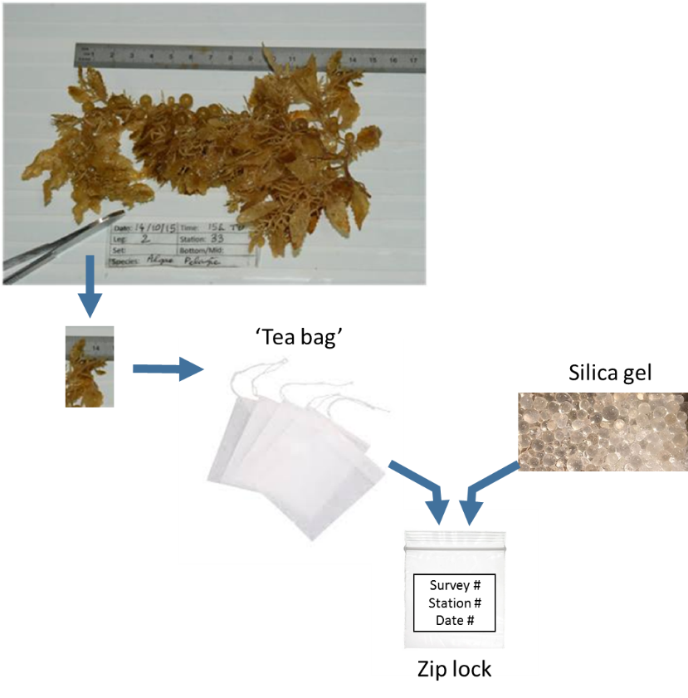

Taxonomy and biology purpose

Collect as much as possible samples of pelagic algae. Put the entire algae (if the algae is too large take a sub-sample and estimate the sub-sample size) and the associated fauna in a plastic bottle, labelled (survey name, station #, date, sample number, type of sample). Fix with formaldehyde 4% (diluted with seawater if possible).

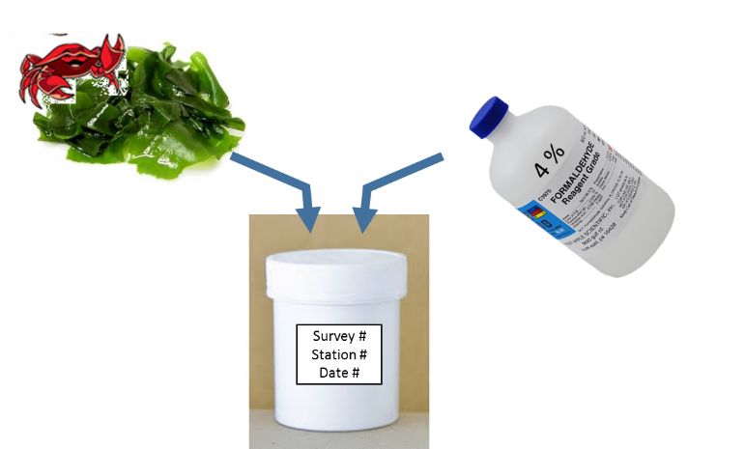

If not possible to use formaldehyde then freeze (-20ºC) the samples in labelled plastic bags.

**1.3. Laboratory analyses**

- Separate the fauna from the algae.

- Identify the algae.

- Estimate the wet weight of the algae. To convert ‘formaldehyde wet-weight’ into dry-wet a conversion factor will be used.

- Estimate its ‘vitality’: colour, texture (firmness), cells integrity

- Identify and take the standards biological parameters of the associate organisms (weight, size, and any other relevant information).

**2. Benthic algae (mainly for ABRAÇOS)**

If algae are captured using the bottom trawl or using the Van Veen grab then sample all algae (if necessary take a subsample but estimate the subsample fraction) in a labelled plastic bag (typically 3l) and freeze at -20ºC. Register the substrate type and if possible take a sample.

**3. Needed material for a given survey**

**3.1. Molecular biology**

* 60 Ziploc 13 x 8.5 cm or 22 x 15 cm.
* 60 tea bags (e.g. http://www.venteweb.fr/produit/vktech-sachets-de-the-vides-jetables-en-papier-filtrant-100-pieces/)
* Absorbent paper
* Silica gel: 1000 g
* Tracing paper (for labelling)
* Permanent pen (for labelling)
* Soft toothbrush (to clean the algae segment, if necessary).

**3.2. Taxonomy – biology**

If possible to use formaldehyde:

* 100 (or less if not possible) plastic jars of different sizes e.g. 500 ml, 700 ml, 1250 ml
* Equivalent of 70 l (or less if not possible) of formaldehyde 4%.
* Tracing paper (for labelling)
* Permanent pen (for labelling)

If not possible to use formaldehyde (frozen at -20ºC):

* 200 Ziploc (or equivalent): 36 x 24 cm, 40 x 30 cm, 50 x 40 cm.
* Tracing paper (for labelling)
* Permanent pen (for labelling)